Create a React Application named “cricketapp”

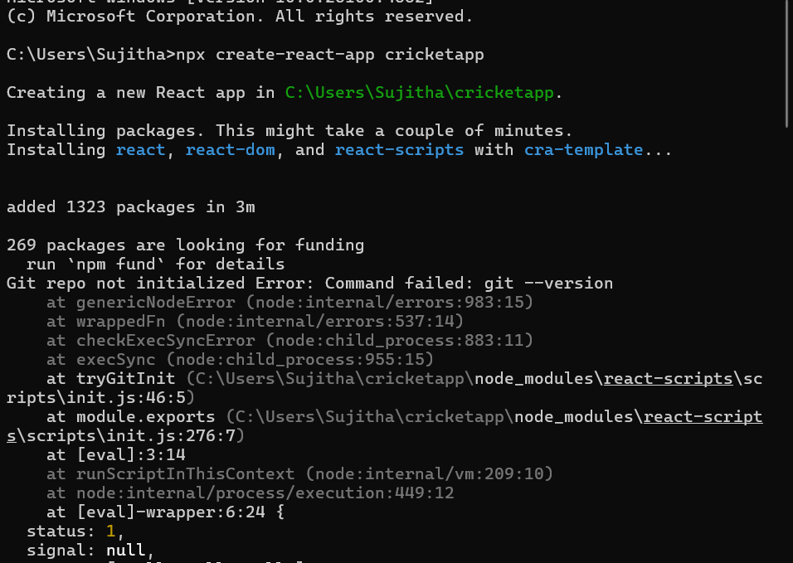

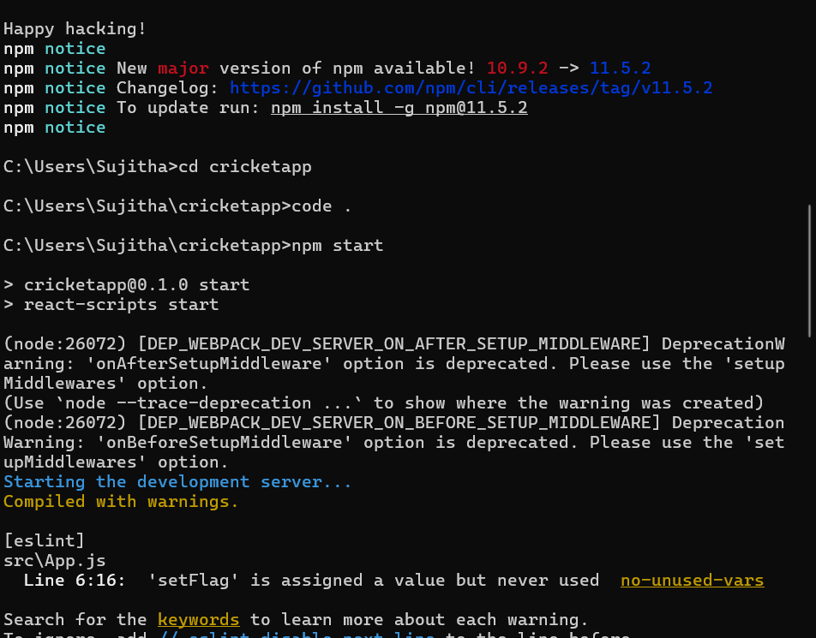

src/App.js

import React, { useState } from 'react';

import ListofPlayers from './ListofPlayers';

import IndianPlayers from './IndianPlayers';

function App() {

  const [flag, setFlag] = useState(true);

  return (

    <div className="App">

      {flag ? <ListofPlayers /> : <IndianPlayers />}

    </div>

  );

}

export default App;

src/ListofPlayers.js

import React from 'react';

function ListofPlayers() {

  const players = [

    { name: "Virat", score: 95 },

    { name: "Rohit", score: 80 },

    { name: "Dhoni", score: 68 },

    { name: "Ashwin", score: 45 },

    { name: "Bumrah", score: 70 },

    { name: "Jadeja", score: 90 },

    { name: "KL Rahul", score: 65 },

    { name: "Shami", score: 55 },

    { name: "Surya", score: 75 },

    { name: "Pant", score: 85 },

    { name: "Iyer", score: 60 },

  ];

  const filteredPlayers = players.filter(player => player.score < 70);

  return (

    <div>

      <h2>All Players</h2>

      {players.map((player, index) => (

        <p key={index}>{player.name} - {player.score}</p>

      ))}

      <h2>Players with score below 70</h2>

      {filteredPlayers.map((player, index) => (

        <p key={index}>{player.name} - {player.score}</p>

      ))}

    </div>

  );

}

export default ListofPlayers;

src/IndianPlayers.js

import React from 'react';

function IndianPlayers() {

  const players = [

    "Virat", "Rohit", "Dhoni", "Ashwin", "Bumrah",

    "Jadeja", "KL Rahul", "Shami", "Surya", "Pant", "Iyer"

  ];

  const oddPlayers = players.filter((_, index) => index % 2 !== 0);

  const evenPlayers = players.filter((_, index) => index % 2 === 0);

  const T20players = ["Virat", "Rohit", "Surya"];

  const RanjiPlayers = ["Rahane", "Shaw", "Pujara"];

  const mergedPlayers = [...T20players, ...RanjiPlayers];

  return (

    <div>

      <h2>Odd Team Players</h2>

      {oddPlayers.map((player, index) => (

        <p key={index}>• {player}</p>

      ))}

      <hr /> {/* horizontal line between sections */}

      <h2>Even Team Players</h2>

      {evenPlayers.map((player, index) => (

        <p key={index}>• {player}</p>

      ))}

      <hr /> {/* another horizontal line */}

      <h2>Merged Players</h2>

      {mergedPlayers.map((player, index) => (

        <p key={index}>• {player}</p>

      ))}

    </div>

  );

}

export default IndianPlayers;

**Output**

When flag=true

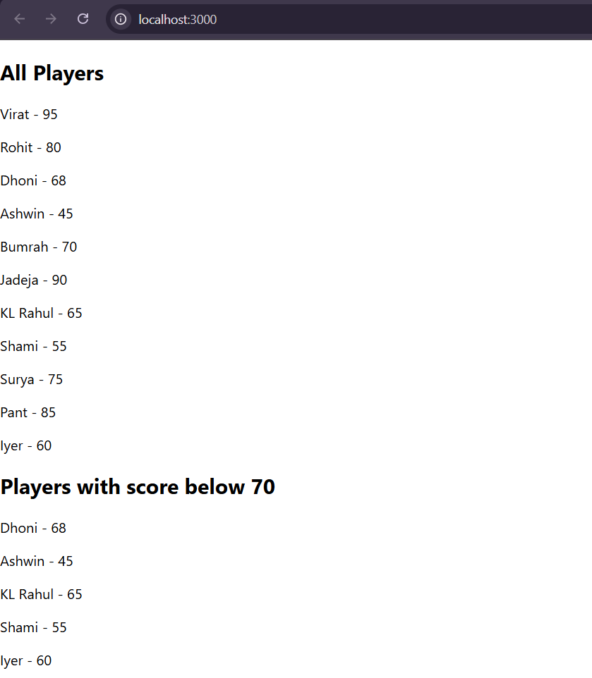

When flag=false

